**LAPORAN PRAKTIKUM**

Nama : AHMAD RUDIANTO

Nim : 21157201114

1. 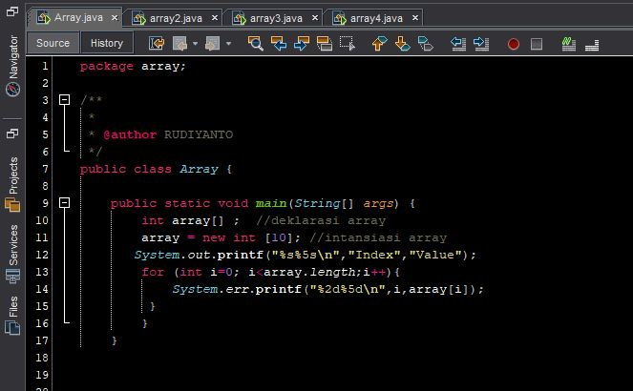**- Percobaan array 1**

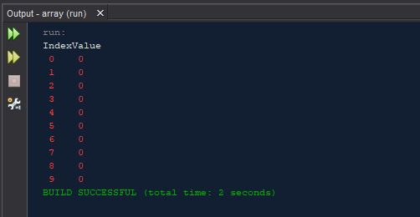**-hasil Running**

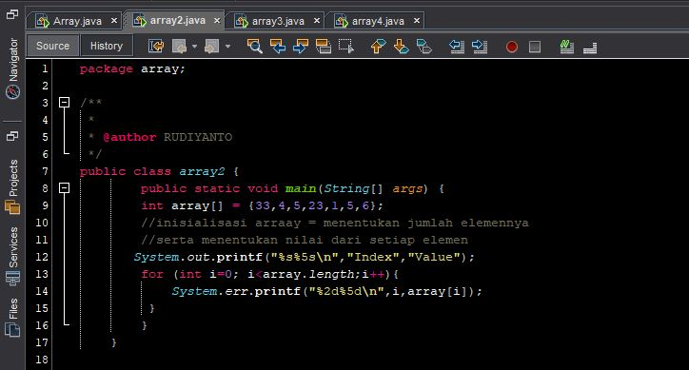**2 - Percobaan array2**

* 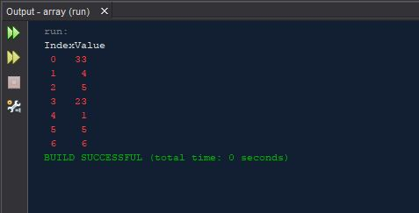**Hasil Runnuing**

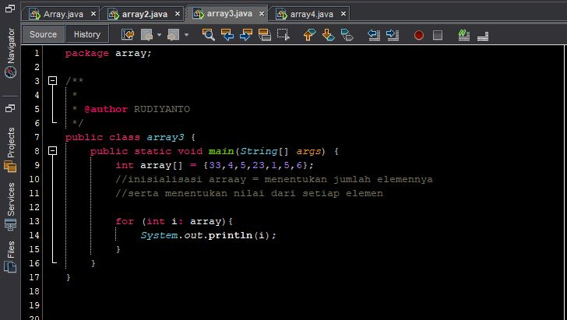**3 – Percobaan array3**

* 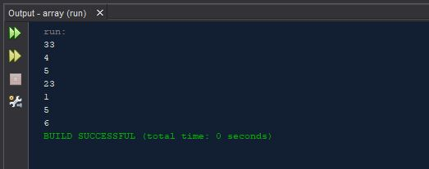**Hasil Running**

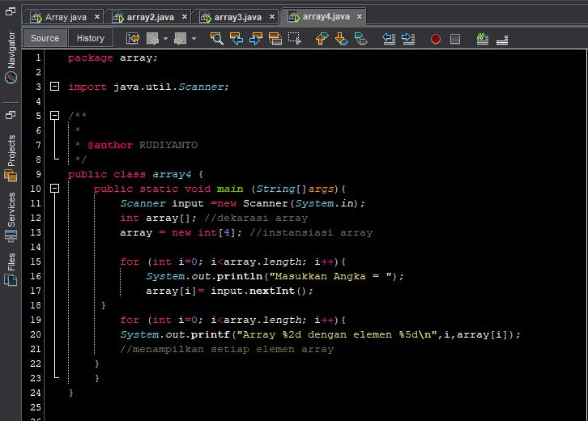**4 – Percobaan array4**

* **Hasil Running**

